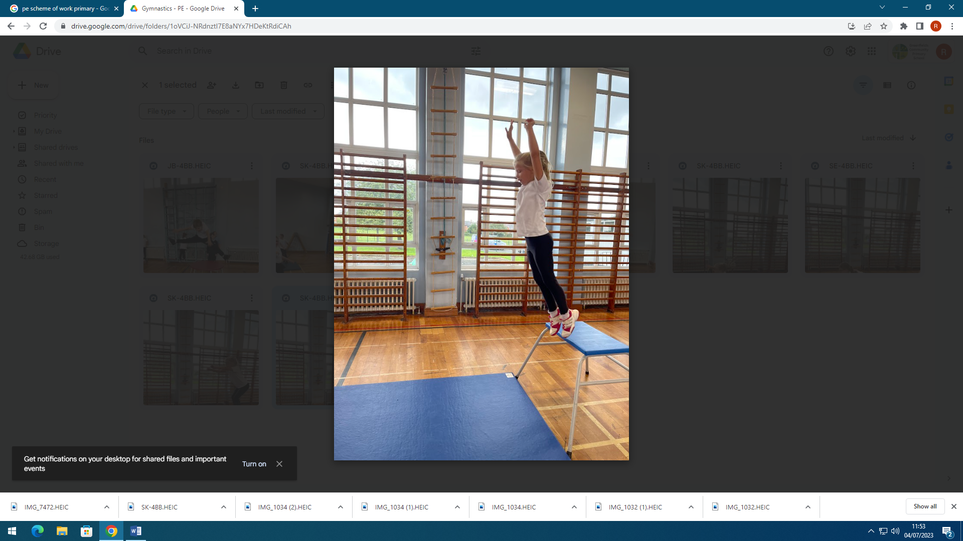
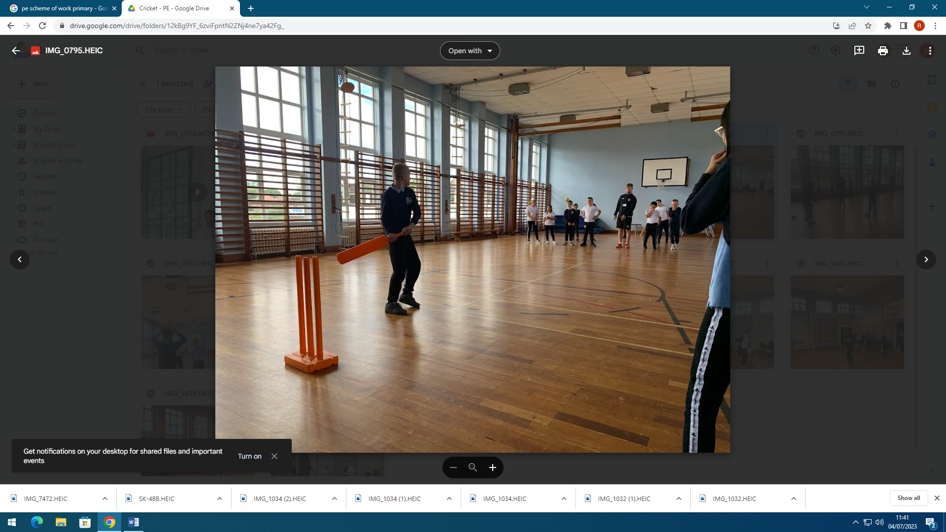
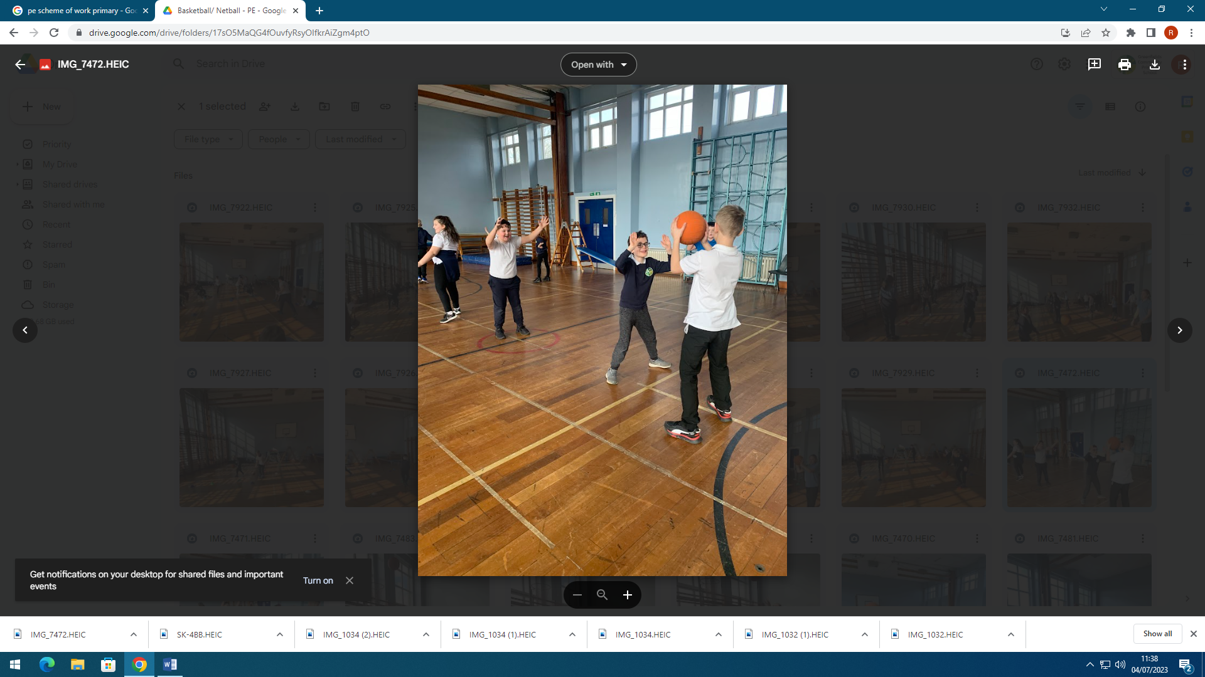
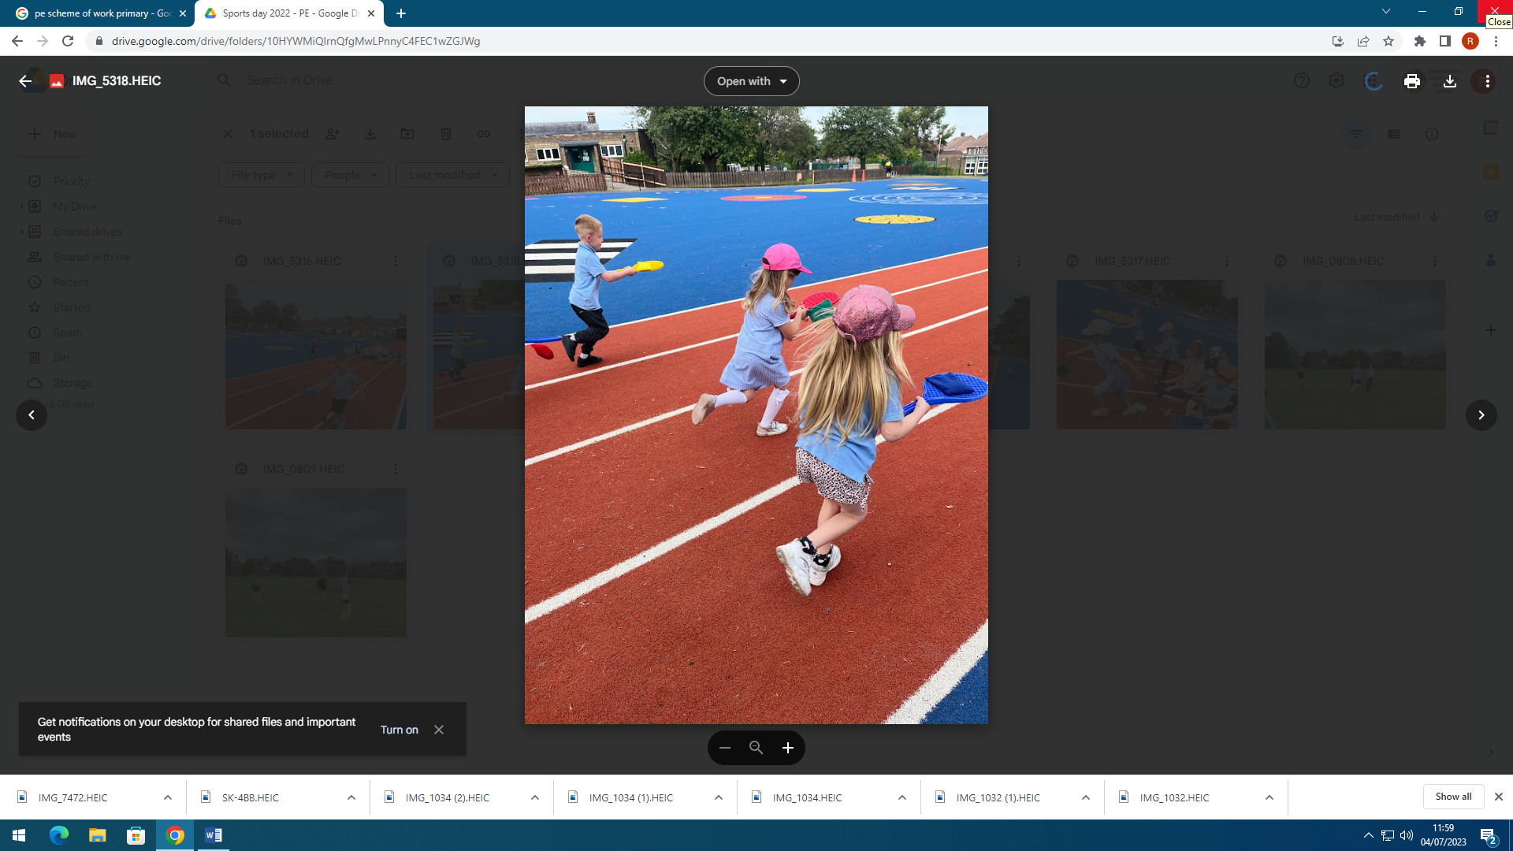
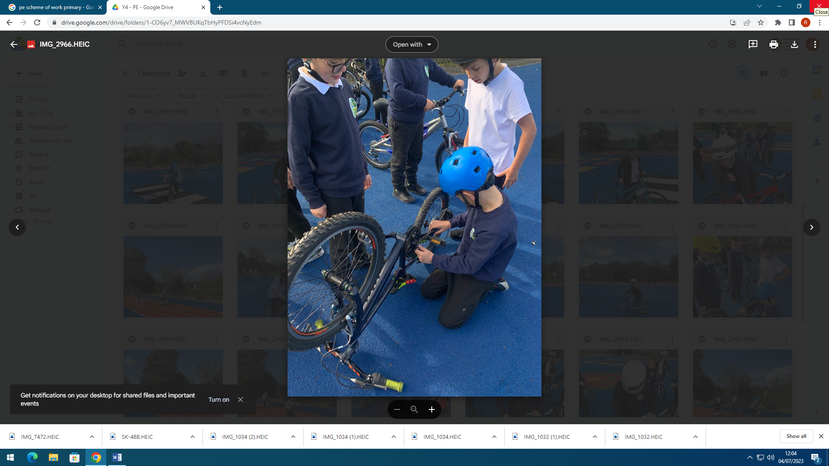
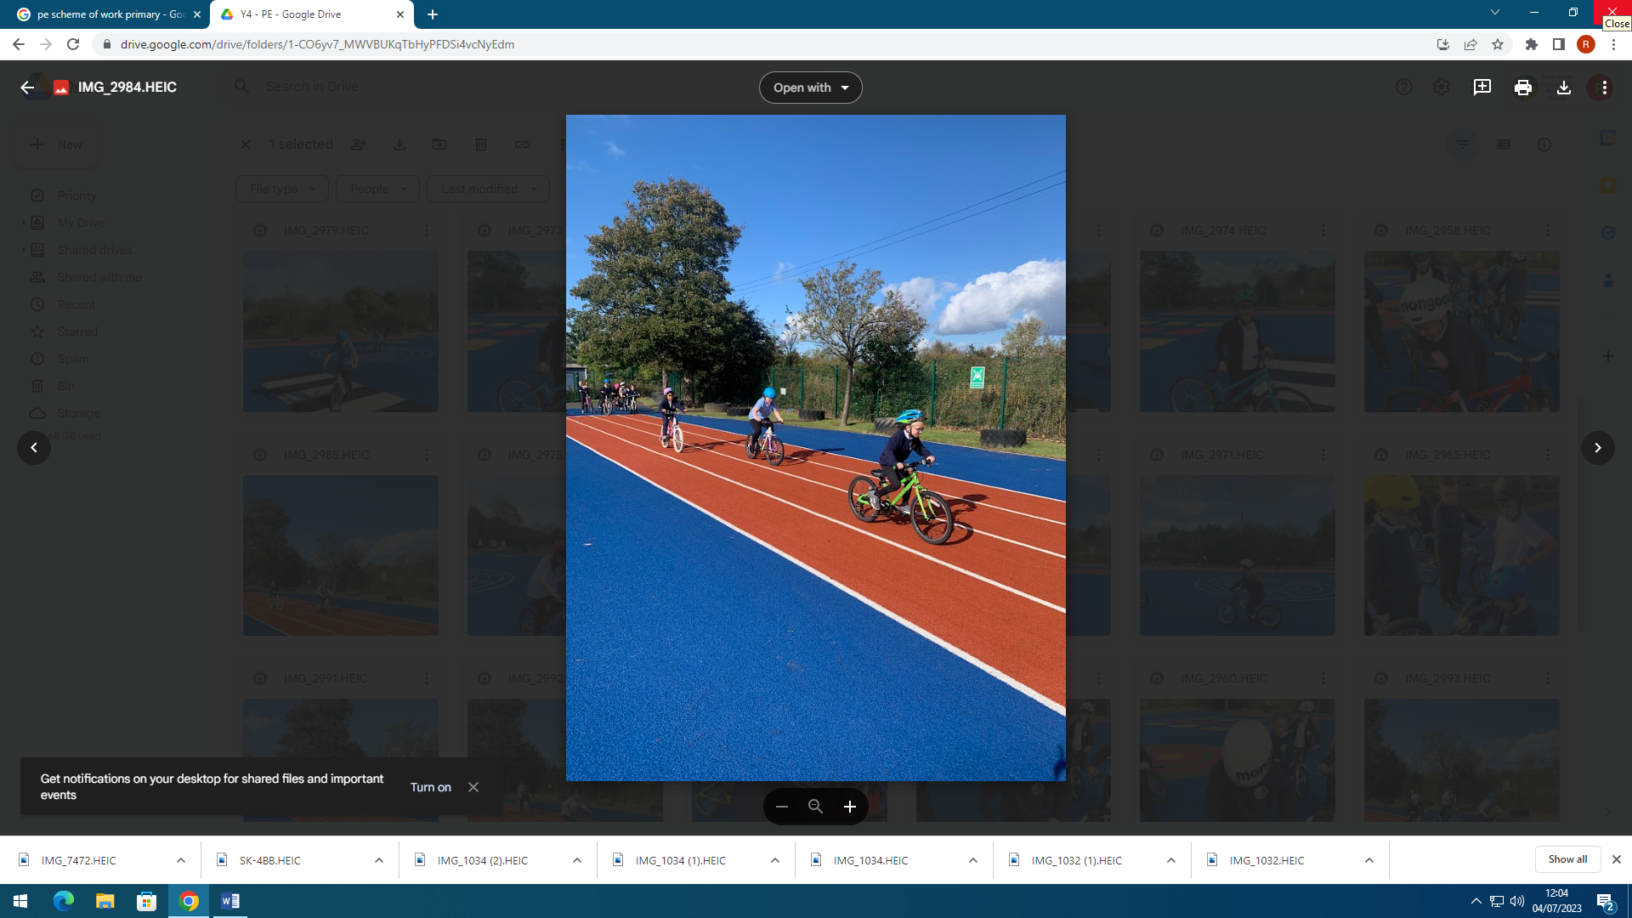

PE & SCHOOL SPORT FUNDING
2023/24

CHANGES & UPDATES
The PE and sport premium must be spent by schools on making additional and sustainable improvements to the provision of PE and sport for the benefit of all pupils to encourage the development of healthy, active lifestyles.
This means that the funding should be used to develop or add to the PE and sport activities that schools already offer and/or make improvements now that will benefit pupils joining the school in future years.
With this in mind, schools can choose how they use the funding.

One of the things that schools are required to publish is the percentage of pupils in the Year 6 cohort who met the national curriculum requirement to:
- swim competently, confidently and proficiently over a distance of at least 25 metres
- use a range of strokes effectively
- perform safe self-rescue in different water-based situations

At Greenfields the % of children who can swim competently, confidently and proficiently over a distance of at least 25 meters, use a range of strokes effectively and perform safe self- rescue in different water-based situations in 2023/24 was 71% which was up from 66% last year.

PE & SCHOOL SPORT FUNDING 2022/23 IMPACT REPORT
Academic year: 2023/24. Total amount allocated: £7475.00 Total amount spent: £9637.20
Key indicator 1: The engagement of all pupils in regular physical activity.
School focus | Actions taken to achieve school focus | Spending | Impact on pupils | Sustainability and next steps
Improve equipment on offer to the children. | - Complete audit of current equipment  - Equipment needs were identified by the PE co-ordinator after conversations with members of staff about what would enable them to deliver high quality PE to all children.  - Discuss with EYFS staff again for their specific needs.  - Equipment ordered inline with new planning. | £322.20 | EYFS staff now have more age appropriate equipment which is making it easier for them to develop gross motor skills and provide better progression through school.  Clear understanding of what we have in school before things are ordered. We know what we have so we can access all areas of the PE curriculum successfully.  Children report that they are happy on the whole with the amount and range of equipment but “we could do with more footballs and a ball pump.” | We only buy what we know we need after a review of the curriculum, this means no unnecessary spending.  Next steps are to ensure the resources are properly cared for and maintained. Children said during pupil voice, “we need more equipment because some of it is really old and we have to share.” – This will mean a more thorough approach to sports leaders in school from September 2024 to keep on top of what we need.

Key indicator 2: The profile of PE and sport being raised across the school as a tool for whole school improvement.
School focus | Actions taken to achieve | Spending | Impact on pupils | Sustainability and next steps
To get children engaged and excited to be more physically active. | - JJ Coaching – We hired JJ coaching to deliver sessions from y1 – y6 throughout the day on a Thursday each week. They have delivered some ball skills sessions as well as covering the balancing units from gymnastics. They also provided extra curricular coaching across the school. | £6541 | Children have had the chance to work on fundamental movement skills which have been transferred to their other PE session in the week. The children said, “I like Mr Fisher’s sessions.” “JJ coaching sessions are fun.” “I enjoy sessions with Mr Fisher. We learn new things every week.” Children who are SEN and working below ARE also said that the coach helps them if they are stuck and that they enjoy their sessions. The profile of PE has been raised and the data supports this, with 87% of pupils working at ARE or above. | JJ’s coaching really engaged pupils’ interest in being active, and teachers comment on the children being more engaged in their other PE lesson in the week. Our next step is to consider the curriculum gaps in the data and the needs of our staff for CPD opportunities. This means we will get external coaching from a gymnastics and dance specialist next academic year.

Key indicator 3: Increased confidence, knowledge and skills of all staff in teaching PE and sport.
School focus | Actions taken to achieve | Spending | Impact on pupils | Sustainability and next steps
SLA access to increase staff resources to enable a broad and balanced curriculum | - School bought into the LA PE SLA. | £1100 | As a result of a continued relationship with the School Development officers and the Local Authority’s SLA we have continued to upskill our staff based on training the PE co-ordinator has received. | Continue to implement the training and information received in the staff meetings delivered by the coordinator. Look into developing training further to look at lesson planning. Without the SLA we wouldn’t have access to the support for the School Games Mark application.
Ensure that P.E. lessons are vocabulary rich, with adults modelling the vocabulary they want children to learn and use and ensure there is accurate and effective assessment in P.E. and that staff are confident with this assessment | - PE passport access – we bought into a PE scheme which has planning available for each year group from nursery to y6. The PE lead has tailored this to provide a broad and progressive curriculum overview and now staff have planning available that is broken down efficiently and with the necessary vocabulary. It also has assessment tools that are easy to use and track. | £629 | SEND adaptations on the planning mean that children are now more included in each PE lesson regardless of need. | Long term this means our staff will become more confident teaching the objectives in a more broken down way and the children will have a better vocabulary relating to the subject. This is sustainable as it is something that will support teachers CPD. Eventually we could move away from it when staff confidence is improved.

Key indicator 4: Broader experience of a range of sports and activities offered to pupils.
School focus | Actions taken to achieve | Spending | Impact on pupils | Sustainability and next steps
Ensure children in all year groups are offered extra  -curricular P.E. activities at some point throughout the school year. | - Anthony from the Newcastle Eagles has been delivering after school club sessions to children in KS2 and is also working with children in KS1 for free to engage children with the sport of Basketball. | £380 | Children spoke positively about the sessions and said, “It makes basketball more fun” and “I like the coach he helps me get better skills.”  Children have also been headhunted to progress to club level through the Eagles development pathway and we also now run an after-school club which has been offered to children from y2-6. | We have agreed a subsidized price with the Eagles in exchange for use of our gym facilities so the coach can run a community club on a Thursday evening. This is improving links with the communities and something we could look at developing further with other companies in the future.  Next steps would be to see what other clubs could be offered next year to target the reception children coming into y1 as their data is noticeably lower than the rest of the school.

Key indicator 5: Increased participation in competitive sport.
School focus | Actions taken to achieve | Spending | Impact on pupils | Sustainability and next steps
Transport and competitions. | - Minibuses booked to take children to and from competitions  - Appropriate staffing ratios and First Aiders provided for all trips to competitions  - Skipping festival | £665 | This year there have been multiple year groups out at competitions. The boys’ football has been a big success under Mr Watson and Mr Lumsdon. We also attended the Dance festival, the Y5/6 hockey festival, The Y4 Skipping festival and Quadkids athletics competitions for y1 and y5. We are now attending more events school wide compared to last year. | Some of the tournaments we have been part of, we walked to or we hosted in school.  Next steps are to look at what competitions we can attend lower down the school. This will have a more long-lasting impact on the children as they move through school.

PE AND SPORT STRATEGY FOR 2024/25
Academic year: 2024/25 |  | Total amount allocated: £7404
Key indicator 1: The engagement of all pupils in regular physical activity.
School focus | Actions taken to achieve | Funding allocated | Impact on pupils
Enhance the quality of PE being taught and enhance participation during playtimes and lunchtimes. | - Annual teacher survey to find out about what they feel we need more of in order to provide children with higher quality PE both curriculum and extra-curricular.  - Buy more equipment based on teacher survey of what they identify is needed.  - Pupil voice taken into account for more outdoor equipment for playtimes and lunchtimes to ensure they are active times in order to contribute to the Activ8 pledge. | £200
Repairs and maintenance | - Assess equipment  - Replace any equipment that is not fit for purpose/damaged | £200
Key indicator 2: The profile of PE and sport being raised across the school as a tool for whole school improvement.
School focus | Actions taken to achieve | Funding allocated | Impact on pupils
Implement playleaders across school at dinner times and playtimes | - Meet with playleaders to discuss their role, activities and PE equipment they want to use on the playground. | £50
Have a PE display in school to raise the profile of PE. | - Update the display board in school linked to PE with the latest news and updates displayed with what is happening in PE in terms of after school clubs for parents to see.  - Add photos to display clubs and generate interest in future clubs.  - Create a display linked to competitions entered to raise the profile of sport and link this to the school values and other professional sports athletes. | £0
Develop further playleaders within school | - Identify a year group to complete the play leaders award. Play leaders to use their skills at playtime and dinner times to get the other children active in different games. | TBC
Key indicator 3: Increased confidence, knowledge and skills of all staff in teaching PE and sport.
School focus | Actions taken to achieve | Funding allocated | Impact on pupils
Develop a clearer planning process to make curriculum PE more rigorous | - Reinvest into PE Passport scheme to continue to provide planning and also clear tracking/ evidence/ assessment across the school – PE Passport. | £650

Key indicator 4: Broader experience of a range of sports and activities offered to pupils.
School focus | Actions taken to achieve | Funding allocated | Impact on pupils
External coaching | - External clubs to run after school targeting the children identified as underachieving in their end of year report data.  - Curriculum support for Dance and Gymnastics – S.M to deliver dance one afternoon per week and in talks with Gymnastics coach for 1 afternoon per week. | £6000

Key indicator 5: Increased participation in competitive sport.
School focus | Actions taken to achieve | Funding allocated | Impact on pupils
Obtain School Games Mark  – Gold level | - Enter more competitions run using the school games format.  - Book transport for events  - External coaching to deliver extra-curricular coaching throughout the year to support with School Games Mark competitions.  - Additional staff support for ratios and first aid. | £500

